Sintering Oven Temp Tab SOP

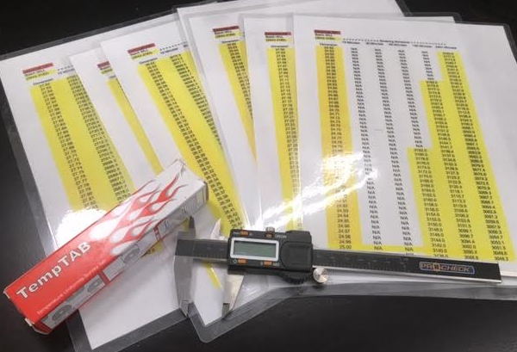

This procedure assumes that you have been properly trained on the use of MIHM VOGT HT series sintering ovens by a senior operator of TSD CAM. Please refer to previous training for proper operation of ovens. DO NOT attempt this procedure if you are not familiar with running CAMs sintering ovens.

Place a temp tab in the center of sintering tray with or without crowns to be sintered.

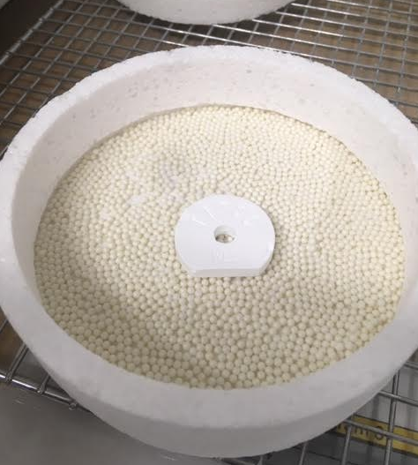

Sinter on appropriate program per your training.

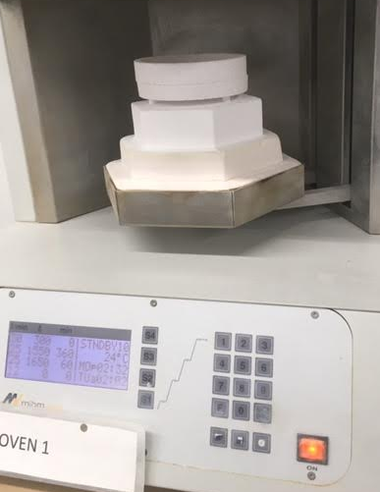

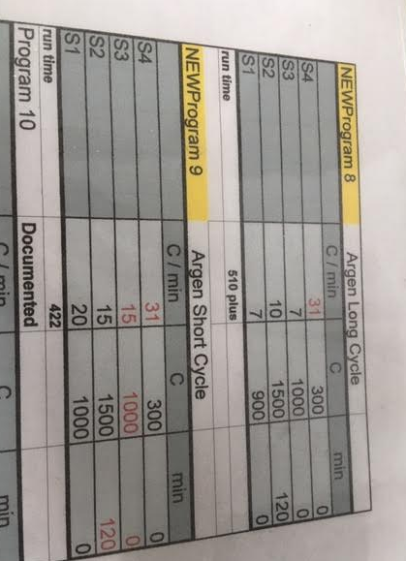

Upon completion of the oven cycle, measure the outside dimension of the temp tab.

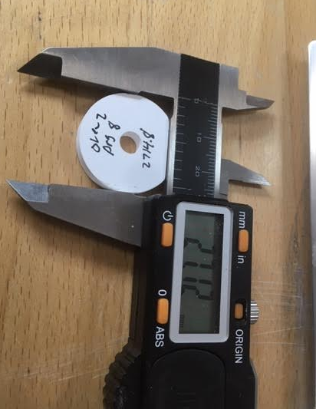

Use the dimension measured and soak time of the program used to find the equivalent temperature using the conversion chart.

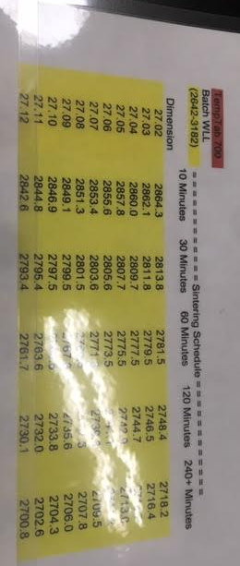

Convert the chart temperature to Celsius to see how close you were to the program’s soak temp.

Fahrenheit to Celsius conversion chart / formula (32**°F** − 32) × 5/9 = 0**°C**

Adjust specific oven’s soak temp if necessary (discrepancies larger than 10 degrees are usually adjusted).

*******Altering oven programs is prohibited without management approval*******

Document all results in maintenance log per training.

